Prospective Sponsor Packet

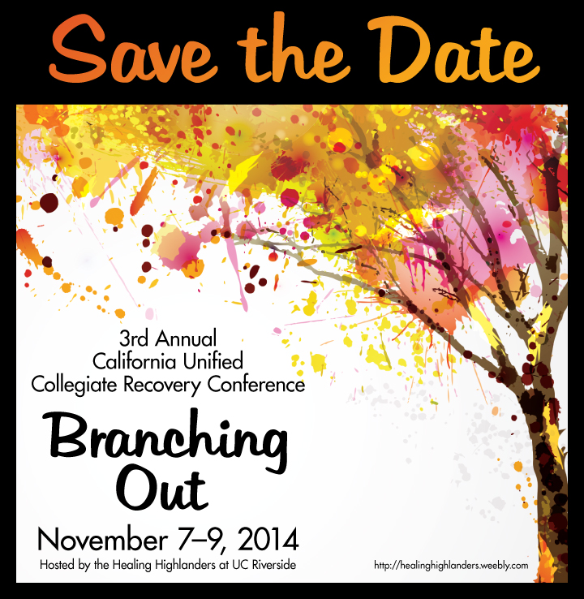

3rd Annual California Unified Collegiate Recovery Conference

November 7-9th, 2014

University of California, Riverside

http://healinghighlanders.weebly.com/

Dear Prospective Sponsor:
The Healing Highlanders at the University of California, Riverside, would like to invite you to the 3rd Annual California Unified Collegiate Recovery Conference, held on November 7–9, 2014 on the University of California at Riverside, campus. The primary goals for this year’s conference will place significant emphasis on developing partnerships with community and private agencies, promoting holistic wellness, and highlighting how we can be an asset to one another when we share resources.
The Healing Highlanders at UCR is a group of students devoted to building a supportive and nurturing environment in which students in recovery from addictive disorders can flourish. We aim to provide students in recovery with the resources they need in order to thrive academically, socially, and professionally. Our group consists of both students in recovery and their allies, working together to eradicate the stigma associated with addiction on our campus.
Our previous conferences have attracted nearly 200 students, faculty, staff, and clinicians from across the nation. As a result of the inaugural conference’s success, the Healing Highlanders received the 2012 UC Presidential Award for Outstanding Leadership, the most prestigious award available via the UC system. The University of California, Riverside, also voted the conference the 2012 Outstanding Educational Program of the Year.
In 2013, the Healing Highlanders’ continuous efforts to rally the UC system to come together for an amazing cause was rewarded via the enhanced interest in these types of programs by the University of California Office of the President (UCOP). This energy resulted in UCOP hosting a Collegiate Recovery Retreat to continue expanding the impact of recovery programs within the UC system as well as additional public and private institutions within California. This seal of approval by the highest office within our university system shows the progress our past conferences and partnerships have had on accelerating the Collegiate Recovery movement within the state. At the 3rd annual California Unified Collegiate Recovery Conference, we hope to continue those conversations and further the movement within the western region of the nation.
In order to make this conference possible, we will need the support of multiple sponsors. We would therefore like to invite you to partner in our mission by becoming a sponsor for this student-driven event. Your involvement as a sponsor will not only provide much-needed assistance to the Healing Highlanders, but will also provide you and your organization with invaluable benefits – many of which you can read more about below. Should you wish to become a sponsor, you may register by completing the form at the end of this packet and sending it via email or post.
Please email or call with any questions. Thank you for your time, and we look forward to hearing from you soon.
Sincerely,

The Healing Highlanders at UCR

CUCRC SPONSOR LEVELS
Highlander Level Sponsor - $10,000
1. Primary Sponsor Recognition on conference material
2. Public recognition during the welcoming and closing address
3. Opportunity to briefly address conference attendees at one conference-wide event
4. Your company video (or a video interview of you) posted on conference website.
5. VIP campus tour with the Healing Highlanders
6. Funding of financial assistance for six (6) student registrations
7. Full-page ad in the exhibitors’ packet for conference attendees
8. Eight (8) registrations for the conference
9. One premier table to exhibit during the entire conference
10. Company Logo on the CUCR conference website
11. Placement of company signage at entire event
12. Your company materials in attendee bags
13. Opportunity to sponsor one meal, premier company signage included

Tartan Level Sponsor - $5,000
1. Public recognition during the welcoming and closing address
2. Funding of financial assistance for three (3) student registrations
3. Half-page ad in exhibitors’ packet for conference attendees
4. Four (4) registrations for the conference
5. One premier table to exhibit during the entire conference
6. Company Logo on the CUCR conference website
7. Placement of company signage at entire event
8. Ability to insert materials into attendee bags
9. Opportunity to sponsor one meal, premier company signage included

Gold Level Sponsor - $2,500
1. Public recognition during the welcoming address
2. Funding of financial assistance for one (1) student registration
3. Quarter-page ad in exhibitors’ packet for conference attendees
4. Three (3) registrations for the conference
5. One table to exhibit during the entire conference
6. Company Logo on the CUCR conference website
7. Placement of company signage at entire event
8. Ability to insert materials into attendee bags
9. Opportunity to sponsor one meal, premier company signage included
Blue Level Sponsor - $1,000
1. Company Logo in exhibitors’ packet for conference attendees
2. Two (2) registrations for the conference
3. One table to exhibit during the entire conference
4. Company Logo on the CUCR conference website
5. Placement of company signage at entire event
6. Ability to insert materials into attendee bags

Citrus Sponsor - $500
1. Company Logo in exhibitors’ packet for conference attendees
2. One (1) registration for the conference
3. Company Logo on the CUCR conference website
4. Ability to insert materials into attendee bags

CUCRC REGISTRATION FORM
Section I – Sponsor Profile
One Free Registration included at the Citrus Level (all conference meals are included) Two Free Registrations included at the Blue Level (all conference meals are included)
Three Free Registrations included at the Gold Level (all conference meals are included)
Four Free Registrations included at the Tartan Level (all conference meals are included)
Eight Free Registrations included at the Highlander Level (all conference meals are included)

First Name_______________________ Middle Initial_____ Last Name_______________________
Badge Name______________________________________ Title___________________________
Business or Organization ___________________________________________________________
Mailing Address___________________________________________________________________
City________________________________ State_________________________ Zip____________
Phone _____________________________________ Fax _________________________________
E-mail Address ___________________________________________________________________
Additional Sponsors Attending
Badge Name______________________________________ Title___________________________
E-mail Address ___________________________________________________________________
Phone _____________________________________ Fax _________________________________
Badge Name______________________________________ Title___________________________
E-mail Address ___________________________________________________________________
Phone _____________________________________ Fax _________________________________

Badge Name______________________________________ Title___________________________
E-mail Address ___________________________________________________________________
Phone _____________________________________ Fax _________________________________

Badge Name______________________________________ Title___________________________
E-mail Address ___________________________________________________________________
Phone _____________________________________ Fax _________________________________

Badge Name______________________________________ Title___________________________
E-mail Address ___________________________________________________________________
Phone _____________________________________ Fax _________________________________
(If you have additional registrations, please add an additional sheet to your sponsorship packet indicating the above information for each individual in your party).

Section II – Package
Sponsorship Level Purchasing: ________________________________ = $ ___________________
Number of Free Registrations at Your Level: Citrus = 1, Blue = 2, Gold = 3, Tartan = 4, Highlander = 8
Additional Conference Registration: _____________________________ = $ __________________
Badge Name______________________________________ Title___________________________
E-mail Address ___________________________________________________________________
Phone _____________________________________ Fax _________________________________
Additional Conference Registration: _____________________________ = $ __________________
Badge Name______________________________________ Title___________________________
E-mail Address ___________________________________________________________________
Phone _____________________________________ Fax _________________________________
Section II Subtotal $____________

Section III – Logistics
Do you need to have access to a power source? YES NO

Section IV – Meals
Does anyone in your group have specific dietary needs? Please list any needs for each member of your group.

Vegan? Vegetarian? Allergies?____________________________
Section V – Silent Auction
Would your agency be willing to donate an item to our Silent Auction at the conference? All proceeds will go toward student scholarships. YES NO

Please submit your completed Sponsorship Registration Form to Audrey Pusey via email at audrey.pusey@ucr.edu or via mail using the address below.
Payments will be accepted by check only and should be payable to: UC Regents.
Healing Highlanders at UCR,
c/o Audrey L. Pusey, Advisor
500 W. Big Springs Rd.
Riverside, CA 92507

